|  |  |
| --- | --- |
| KSU_logo.jpg | **King Saud University**  **College of Computer and Information Sciences**  **Department of Computer Science** |

**CSC 220: Computer Organization**

**Labwork - #2**

**Name: Saud Amer alkahtani,id:436102946,day:Sunday,Hour:4to6pm**

1. **Introduction**

In this lab-work I learned how to compare between 2 logic circuits and see which one has fewer gates

1. **Experiments**

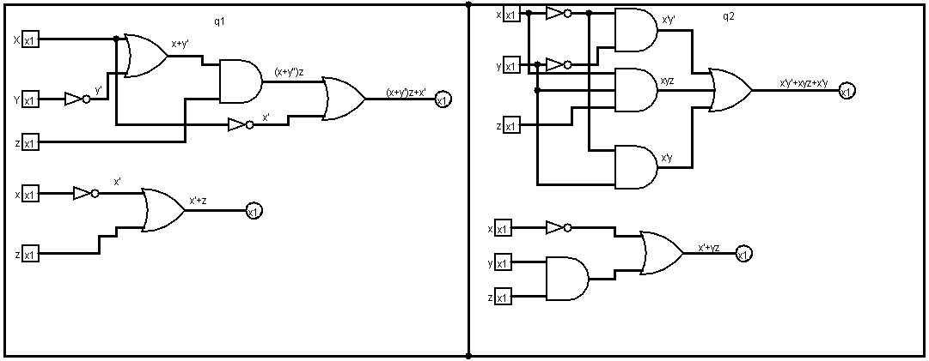

1. **Results**

**Q1) truth table:**

|  |  |  |  |  |  |  |
| --- | --- | --- | --- | --- | --- | --- |
| **X** | **Y** | **Z** | **X+Y’** | **(X+Y’)Z** | **(X+Y’)Z+X’** | **X’+Z** |
| **0** | **0** | **0** | **1** | **0** | **1** | **1** |
| **0** | **0** | **1** | **1** | **1** | **1** | **1** |
| **0** | **1** | **0** | **0** | **0** | **1** | **1** |
| **0** | **1** | **1** | **0** | **0** | **1** | **1** |
| **1** | **0** | **0** | **1** | **0** | **0** | **0** |
| **1** | **0** | **1** | **1** | **1** | **1** | **1** |
| **1** | **1** | **0** | **1** | **0** | **0** | **0** |
| **1** | **1** | **1** | **1** | **1** | **1** | **1** |

**Q2) truth table:**

|  |  |  |  |  |  |  |  |
| --- | --- | --- | --- | --- | --- | --- | --- |
| **X** | **Y** | **Z** | **X’Y’** | **XYZ** | **X’Y** | **XY+XYZ+X’Y** | **X’+YZ** |
| **0** | **0** | **0** | **1** | **0** | **0** | **1** | **1** |
| **0** | **0** | **1** | **1** | **0** | **0** | **1** | **1** |
| **0** | **1** | **0** | **0** | **0** | **1** | **1** | **1** |
| **0** | **1** | **1** | **0** | **0** | **1** | **1** | **1** |
| **1** | **0** | **0** | **0** | **0** | **0** | **0** | **0** |
| **1** | **0** | **1** | **0** | **0** | **0** | **0** | **0** |
| **1** | **1** | **0** | **0** | **0** | **0** | **0** | **0** |
| **1** | **1** | **1** | **0** | **1** | **0** | **1** | **1** |

**4. Discussion**

In this lab work I found that sometimes complicated circuits can have easier ways to do them as we see in the output from the question1 circuit 1 and 2 that they show the same output

Which means we can lower the cost of having these many gates in our circuit.